

**LETTER OF RECOMMENDATION**

It is to certify that **Ms. Arpita Das Ref no.PS22DA2538** and **D/O**

**Mr. Bijan Behari Das** and resident of Tripura has been serving in the

Organizationsince **5th Oct to 5th Dec 2022** as **Data Analyst.**

During this tenure of **Ms. Arpita Das** remained involved in her work

like data scrapping, problem solving of new interns. We found she is pretty

active in whatever task; we have provided her. She is a confident person.

She is professionally sound, hard-working and a devoted staff. She has the

motivation to take initiative tasks and we are gratified that she has been

helpful in the advancement of our organization.

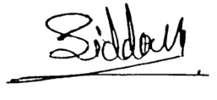

Regards,

Siddayya Swamy

Founder & CEO